All Information on this page needs to be replaced with the information below.
http://www.gulfatlanticequipment.com/products-log-washers.php

Log Washers

Best known for its ability to remove tough, plastic clays from natural and crushed gravel, stone and ore feeds, the McLanahan Log Washer has been a staple in the aggregate and mining industries since its conception by Samuel Calvin McLanahan in 1894. The McLanahan Log Washer has evolved to become the most advanced and innovative Log Washer used and trusted around the world today.
This Log Washer removes deleterious clays and coatings from hard rock and various ores and is capable of accepting feed material up to 6” cubed.
Eliminate out of spec products contaminated with clay, silts and other deleterious materials by using the McLanahan Mudmaster and Super Mudmaster Log Washers. Used around the world for washing gravel, cemented aggregates, limestone, phosphate and various ores, McLanahan Log Washers have set the standard by which all others are measured. These high quality, highly durable machines perform well under the toughest clay conditions with minimum power, water, and downtime. Contact Gulf Atlantic to find out how a McLanahan Log Washer can benefit your operations.

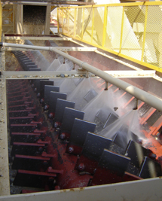  Click Photo to Watch the Video!  Click Here For Brochure!   How Does a Log Washer Work?  Click Here To Find Out! | LOG WASHER USES:  - Remove clay, silts and other deleterious materials  - Used around the world for washing gravel,  cemented aggregates, limestone, phosphate and various ores  - Operates in the toughest clay conditions with minimum power, water and downtime.  Available Sizes:  Mudmaster Log Washers:  - 36” diameter paddle swing  available in 25’ and 30’ lengths  - 38” diameter paddle swings available in 30’ and 35’ lengths  Super Mudmaster Log Washers:  - 46” diameter paddle swings  available in 30’ and 35’ lengths | APPLICATIONS:  - Best known for its ability to remove tough, plastic clays from natural and crushed gravel, stone and ore feeds.  - Capable of accepting feed material up to 6” cubed, the Log Washer removes deleterious clays and coatings from hard rock and various ores.  - As the percentage of deleterious material to be removed increases, longer units should be used in order to increase the washing action. In very severe applications two or more Log Washers may be required.  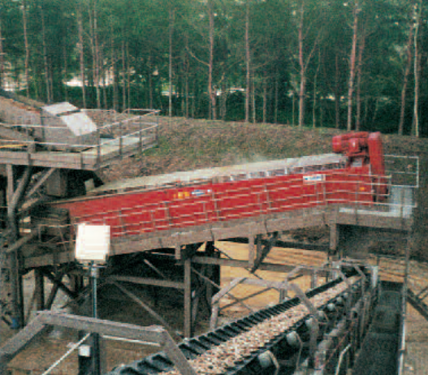

Video URL: http://www.youtube.com/watch?feature=player_embedded&v=GhPe6NldQvE

McLanahan log washer Design Features  - BOX DESIGN: All McLanahan Log Washers use standard heavy-duty boxes  that are diagonally reinforced on the bottom and vertically along  the sides to provide for years of maintenance-free use.  - DRIVES: All McLanahan Log Washers employ a v-belt driven, single input,  dual output gear reducer, which can be uncoupled from the log shafts  and frame for maintenance. Helical gearing incorporates 50% more  horsepower capacity than conventional spur gear design reducers.  - SLOPE ADJUSTMENT: Log Washers should be run at minimum slope to reduce parts  wear, power consumption, and maximize capacity. McLanahan Log  Washers are available with standard slope adjustments using a  trunnion support at the center bottom of the washer box or adjustable  support brackets can be furnished at each of the four corners where  two screw jacks provide for a quick change as needed.  - PIPE SHAFTS: Seamless pipe has an extra thick wall and the shafts are flanged at  each end to facilitate maintenance. Each shaft is then straightened  to our tight standards to ensure maximum life.  - SUBMERGED REAR BEARING: All McLanahan Log Washers use our Twin Seal-Pak  rear submerged bearing. This design has been in use since the  mid-1960s and thousands of bearings are currently in use. The  Duo-Cone® seals keep water and the smallest particles from  reaching the bearing. This system is nearly maintenance-free.  - PADDLES: The McL5X paddle is standard on all McLanahan Log Washers and  is designed to optimize the combination of hardness and ductility to  maximize abrasion resistance. This specially developed fine grain steel  is subject to a proprietary quench process that produces a minimum  through hardness of 500 Brinell while maintaining its tensile strength.  McL5X will not break during shipment or crack during installation.  Additionally, the design reduces drag coefficient and thus power  consumption during operation. Each paddle is secured by two  bolts with lock nuts.  - PADDLE DESIGN: McLanahan Log Washers are available with either straight or spiral  rows of paddles. However, shafts with straight rows of paddles are the  most beneficial design because more horsepower is transmitted to  scrubbing action yielding more profitable production.  - SPRAY BARS: All McLanahan Log Washers come standard with a center spray bar to  provide a final rinse before material is discharged from the box, enabling  removal of residual coatings and/or films.  - REDUCERS Reducers are custom engineered and built to McLanahan exacting  standards. The gearboxes use high service factors and AGMA ratings  on gearing. The gears and the unit itself are designed for years and years  of trouble-free service. | 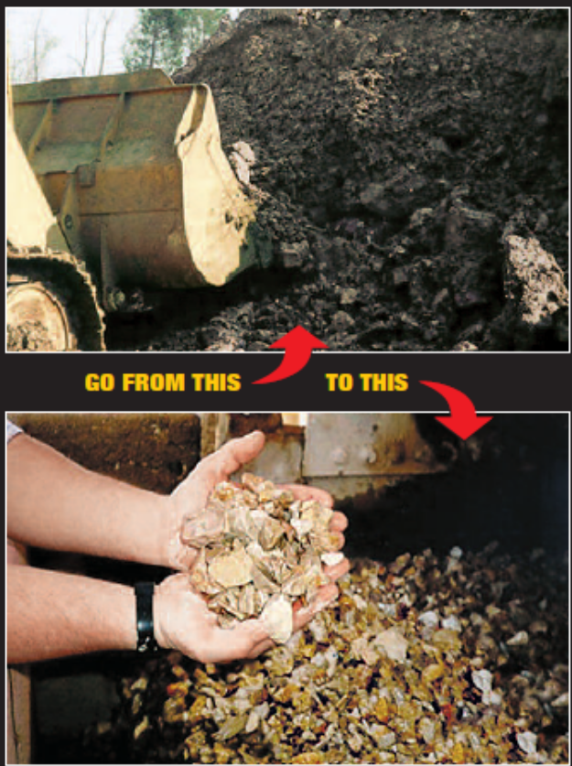

Log Washer Sizing and Selection
The length of a Log Washer directly affects the retention time of the material being washed. The longer the washer box, the higher the retention time. Feed material is normally delivered between the two log shafts two to four feed from the back plate of the washer box.
It is important to consider the size and shape of the feed material as they will dramatically affect the capacity of a particular unit. Log Washers handling crushed or angular material will have a lower capacity than a unit handling round or natural material.
Call Gulf Atlantic (800) 792-7427 for More Information on McLanahan Log Washer SIZING AND SELECTION:
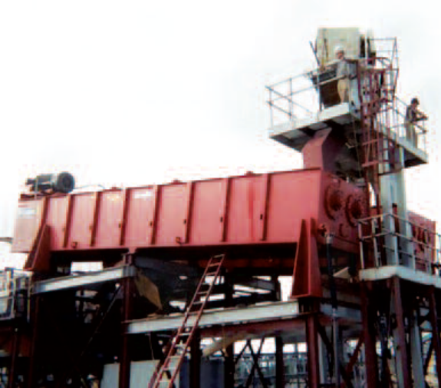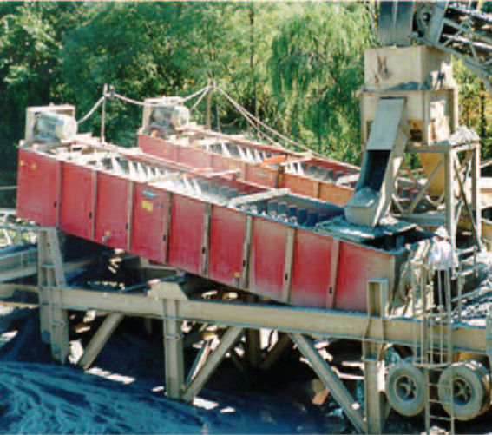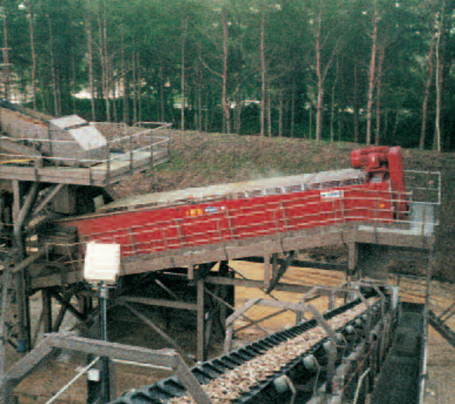

For more information or to receive a quotation on McLanahan Log Washers, click here

Or call (800) 792-7427 or (352) 628-6674


